American Green Solutions: Ensuring Performance for Commercial Solar Owners & Operators

Performance Assurance

Experience the power of purpose-built AI-powered monitoring technology combined with solar O&M expert support for your assets. American Green Solutions is an industry-leading asset performance management solution trusted by over 250 C&I solar developers, owners, and operators nationwide. We offer custom-tailored solutions to meet your unique needs.

Protect Your Investment

Rest easy knowing that your clean energy investments are safeguarded with dedicated expert support from American Green Solutions. Our proprietary technology, coupled with a team of solar experts, promptly notifies you the moment an issue is detected. When service is required, your dedicated portfolio operations manager(s) will coordinate a rapid response through your team or our nationwide field service network, ensuring prompt resolution.

Move Beyond Traditional Monitoring

Break free from traditional monitoring methods with American Green Solutions' innovative approach. Our proprietary technology creates a digital twin of your assets and integrates live, satellite-derived weather data to model performance. Utilizing machine learning and AI, we continuously monitor your real-world assets for underperformance, filtering and analyzing component-level alerts to identify, diagnose, and drive remediation. By filtering out false or irrelevant alerts and remotely resolving more than half of all issues without human intervention, we optimize resource allocation and ensure fast, focused issue resolution.

Reduce Operating Expenses

American Green Solutions streamlines operations by managing monitoring, false alert filtering, remote diagnosis, service coordination, and field service partner relationships. With our remote diagnostic capabilities, we reduce truck roll costs by scheduling on-site visits only when necessary. Our data science team has demonstrated a remarkable 60% reduction in corrective maintenance costs across our commercial solar portfolio.

Remove Geographic Limitations

Our vetted nationwide field service network covers over 33,000 zip codes, providing comprehensive protection for your solar farms as your portfolio grows. All operations and maintenance service work is coordinated and reviewed by our team to ensure quality, giving you peace of mind that your assets are in capable hands. Take back your time as we protect your investment through managed preventative and corrective maintenance, as well as auxiliary services such as vegetation management, panel washing, aerial scans, medium voltage management, and QA/QC inspections.

Scale Your Business

With American Green Solutions' Performance Assurance, our solar experts seamlessly integrate into your team, allowing you to focus on growing your PV pipeline. Our turnkey solution provides dedicated portfolio managers, supported by a team of engineers, data scientists, and solar industry veterans, who track the health and production of your assets. Consider us your one-stop shop for guaranteed asset performance.

Streamline Reporting

Reclaim valuable time with easy access to centralized, standardized reporting for all system and performance data, featuring consistent metrics across your entire portfolio. Our unified reporting covers performance metrics, as well as corrective and preventive maintenance reports, relieving the burden of consolidating data from different systems and providers. Gain reliable data at your fingertips, while streamlining financial and ESG reporting.

Guarantee Performance

At American Green Solutions, we not only drive performance but also back it up with a 95% performance guarantee. If you choose to include this guarantee with a system and it generates less than 95% of the annual energy we forecasted during testing, we will cover the shortfall. A case study with a prominent commercial solar developer showcased a 14% increase in the average monthly performance index over six months.

Community Solar Solutions

American Green Solutions is dedicated to maximizing solar farm production and value for C&I scale and Community Solar projects. We deliver industry-leading asset performance management services for landowners and large-scale solar asset owners and operators. By leveraging our advanced proactive monitoring solution, we can identify potential issues before they escalate. Our team of vetted technicians, available locally across the U.S., provides preventive and corrective maintenance, along with auxiliary services

**NEW Content data**

->[*Residential installers*](https://www.omnidian.com/solutions/solar-performance-assurance-residential-installers/)

[Performance Assurance |](https://www.omnidian.com/solutions/solar-performance-assurance-residential-installers/#:~:text=Performance%20Assurance%20%7C%0AFlexible%20Plans)

Our Dealer Program allows you to include American Green peace of mind and Performance Assurance with every new system. And with our Fleet Operations Program we will manage your existing systems on your behalf.

[Increase Customer Satisfaction](https://www.omnidian.com/solutions/solar-performance-assurance-residential-installers/#:~:text=Increase%20Customer%0ASatisfaction)

Performance Reports are sent throughout the year to track your customers’ energy generation relative to their year-end cash-back energy guarantee. Customer support is a call or click away with online service requests and live support from solar experts with real-time access to your customers’ system analytics.

->[Portfolio Investors](https://www.omnidian.com/solutions/solar-performance-assurance-for-portfolio-investors/#:~:text=a%20Sales%20Exec-,Portfolio%0AInvestors,-Read%20Our%205)

[Optimize Your Return](https://www.omnidian.com/solutions/solar-performance-assurance-for-portfolio-investors/#:~:text=Optimize%20Your%0AReturn)

We assure the performance of your solar assets via rapid issue detection and resolution, and we can even guarantee energy generated at the portfolio or asset level. No adjustment for bad weather: we’ll take the risk.

[Bring Transparency to Performance](https://www.omnidian.com/solutions/solar-performance-assurance-for-portfolio-investors/#:~:text=Bring%20Transparency%0Ato%20Performance)

Our innovative technology and experienced team of solar vets continuously analyze asset performance to identify risks and resolve underperformance. We bring transparency to your entire portfolio, asset by asset.

[24/7 Intelligent Issue Detection](https://www.omnidian.com/solutions/solar-performance-assurance-for-portfolio-investors/#:~:text=24/7%20Intelligent%20Issue%20Detection)

Our technology continually forecasts expected energy generation, based on weather conditions, and flags anomalies. Remote symptom detection and root-cause diagnostics suppress false alerts and weather-related performance variations while firing service tickets to remediate actionable issues.

[Root Cause Diagnostics](https://www.omnidian.com/solutions/solar-performance-assurance-for-portfolio-investors/#:~:text=Root%20Cause%20Diagnostics)

In the real world, multiple issues can overlap to influence performance. Our technology remotely identifies underlying causes and segments the impact of each so our teams can focus on resolving real and actionable issues.

[Operations and Reporting](https://www.omnidian.com/solutions/solar-performance-assurance-for-portfolio-investors/#:~:text=Operations%20and%20Reporting)

We seamlessly integrate billing partners, service networks, CRM systems and monitoring platforms to remove the burden from managing large-scale portfolios and provide a hassle-free ownership experience.

->[Residential-customers](https://www.omnidian.com/solutions/residential-customers/)

[Own Your System](https://www.omnidian.com/solutions/residential-customers/solar-performance-assurance-homeowner-support-own-your-system/#:~:text=a%20Sales%20Exec-,Own%20Your%0ASystem,-Read%20Our%205)

[Set It and Forget it](https://www.omnidian.com/solutions/residential-customers/solar-performance-assurance-homeowner-support-own-your-system/#:~:text=Set%20It%20and%0AForget%20It)

We’ve got you covered, 24/7. American Green technology diagnoses your system’s performance around the clock.

[Intelligent System Diagnostics](https://www.omnidian.com/solutions/residential-customers/solar-performance-assurance-homeowner-support-own-your-system/#:~:text=Intelligent%20System%20Diagnostics)

Shading or soiling? Weather or component failure? In the real world, multiple conditions can overlap. Our technology remotely identifies the root cause. Our experts contact you with a solution.

[Performance Guranteed](https://www.omnidian.com/solutions/residential-customers/solar-performance-assurance-homeowner-support-own-your-system/#:~:text=Performance%2C%0AGuaranteed)

Our 95% cash-back performance guarantee covers the entire year. We guarantee your system’s performance for annual energy generation.

Maneesha

# Services

Solar monitoring analysis involves the use of various technologies to collect and analyse data related to solar energy production. Here are some common technologies used in solar monitoring analysis:

[Solar Monitoring systems](https://trackso.in/trackso-solar/)

Solar Monitoring Systems: These systems include sensors, meters, and data loggers installed in solar power plants or individual solar panels. They measure parameters such as solar irradiance (incoming solar radiation), ambient temperature, panel temperature, and electrical parameters like voltage, current, and power output.

* Collect data from solar inverters & MPPT strings to give accurate insights into your plant’s performance.
* Get detailed insights in solar PV system by monitoring each string & identify anomaly instantly at the right place.
* Monitor energy meters to make sure energy transfer happens with minimum losses, else, identify anomalies instantly.
* Keep track of weather conditions at your plant location to understand or predict generation loss & get instant alerts.

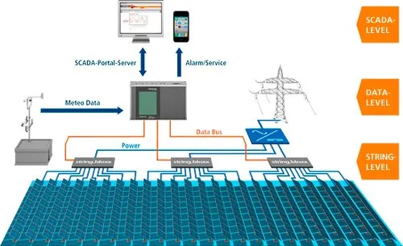

[Weather Monitoring](https://trackso.in/weather-monitoring-system-solar-power-plants/)

Weather Stations: Weather stations provide data on local weather conditions, including solar irradiance, temperature, humidity, wind speed, and direction. This data is crucial for understanding the performance of solar panels and assessing the impact of weather on solar energy generation.

[Data Acquisition Systems](https://trackso.in/knowledge-base/data-acquisition-solar-systems-done-trackso-solar-platform/) Data Acquisition Systems: These systems are responsible for collecting and processing data from various monitoring devices. They often involve data loggers or data acquisition units that gather information from sensors and meters, store the data, and transmit it to a central server for analysis.

Monitoring equipment condition and identification of their performance. Improving the focus on predictive maintenance and reduce the downtime. Optimize plant asset lifecycle and assess asset failure impact. Access to decisions and solutions by domain experts. Ensure compliance to security and safety regulations.

Remote Monitoring and Communication: Remote monitoring systems allow real-time monitoring of solar energy systems from a central location. They use communication technologies such as wireless networks, cellular networks, or satellite communication to transmit data from solar sites to the monitoring centre.

Data Analytics and Software: Advanced software tools are used to analyse the collected data and provide insights into solar energy system performance. These tools may involve algorithms and machine learning techniques to detect patterns, identify anomalies, and optimize energy production.

Sharath

# Services

We provide technology solutions for healthcare and government sectors. Our focus on **Remote monitoring and digital analytics** has helped us provide innovative solutions to clients across the world.

Experiencing frequent downtime with your solar energy system? Or

Having trouble tracking the performance of your equipment across multiple locations?

**Remote Monitoring System** is the solution.

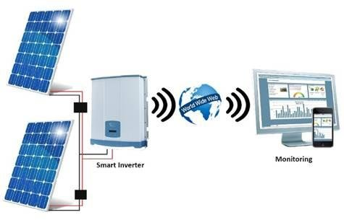

We provide various solutions with our Remote monitoring system to ensure that our client’s solar energy systems and other equipment are operating efficiently. With remote monitoring, we can track system performance in real-time and detect any issues that may arise. This allows us to address issues before they become major problems, reducing downtime and ensuring maximum system efficiency.

[24/7 PV Monitoring:](https://www.solarpowerworldonline.com/2014/09/command-control-247-solar-monitoring-matters%E2%80%A8/)

Our 24/7 PV system monitoring solutions help you to optimize the performance of the solar power systems, reduce downtime and maintenance costs, and ensure that your systems are performing at their best.

Using Our real-time inverter and performance graphing paired with our robust internal metrics, we will help you in:

* Immediate identification of issues and swift resolution. This helps to prevent downtime and ensure that the system is performing at its best.
* Provide detailed performance analysis of solar power systems, including metrics such as energy production, efficiency, and capacity.
* Proactive maintenance of solar power systems, with automated alerts for issues such as equipment failures or low production
* Remote troubleshooting and issue resolution, reducing the need for on-site visits and minimizing downtime.

[Troubleshooting & Repair](https://qesolar.com/services/troubleshooting-repair)

Each step in our process drivers us to maximize assets uptime. Leveraging our 24/7 alerts and response system, Intricate event analysis process, and proactive maintenance practices, we troubleshoot and repair without delay.

Experiencing higher-than-expected energy costs with its solar energy system?

We can help you identify areas where system upgrades could improve efficiency and reduce costs with our **Digital Analytics System.**

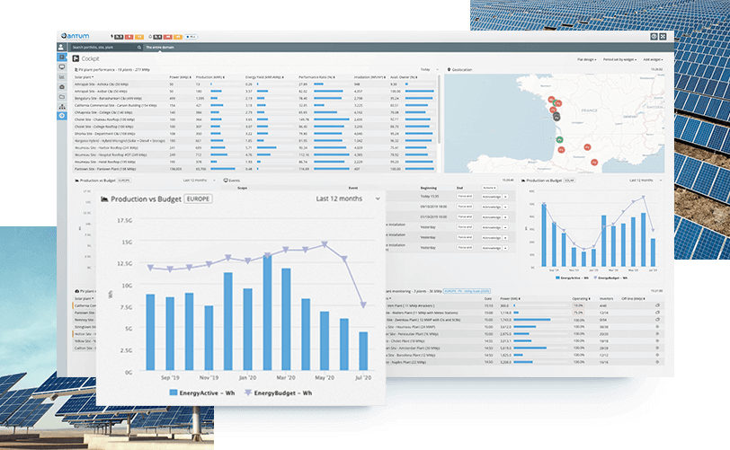

We provide solutions to help you analyse data from solar energy systems and other equipment. By analysing this data, we can identify patterns and trends that can help improve system performance and reduce costs.

[Leverage the power of customized analytics to maximize solar energy production](https://trackso.in/solar-pv-monitoring-and-analytics/)

If you already have a monitoring system, our software seamlessly integrates to give you state-of-the-art Analytics – integral to Quadria's Digital Twin based approach.

All your portfolio data in one centralized cloud location – clean & analysis-ready

1. Accurate, specific, fully actionable O&M Guidance, in form of revenue quantified daily tickets with automated workflows.
2. Scalable, flexible deployment of your own data analytics libraries, KPI calculations etc. directly via Tableau, PBI, Python notebooks etc.

#### [Maintain your solar plants efficiently through Computerized Maintenance Management System (CMMS)](https://terotam.com/solar-energy-power) :

* We help you in better decision making, Improved maintenance planning, Increased equipment reliability, and Reduced maintenance costs.
* Digital Twin based CMMS can help teams collaborate better by providing a shared platform for asset data and maintenance activities. This allows for improved communication between different teams and better coordination of maintenance activities.

### [Power Forecasting:](https://solcast.com/blog/solar-forecasting/how-solar-power-forecasting-works-introduction-basics-FAQ-with-video)

We provide highly accurate predictions of solar energy production based on advanced algorithms and weather data. This helps you to plan your operations more effectively and reduce the risk of production shortfalls. We also provide real-time updates on solar energy production, allowing clients to make timely adjustments to their operations based on changing conditions.

Key Features of our solutions:

* Reduced downtime for solar energy systems and other equipment.
* Improved system efficiency and performance.
* Cost savings through reduced energy usage and improved maintenance.
* Better decision-making through data analysis.